week -12-user-Defined Functions

week -12-user-Defined Functions

coding

reg no:241801289

name:Tamilselvan.k

Q1

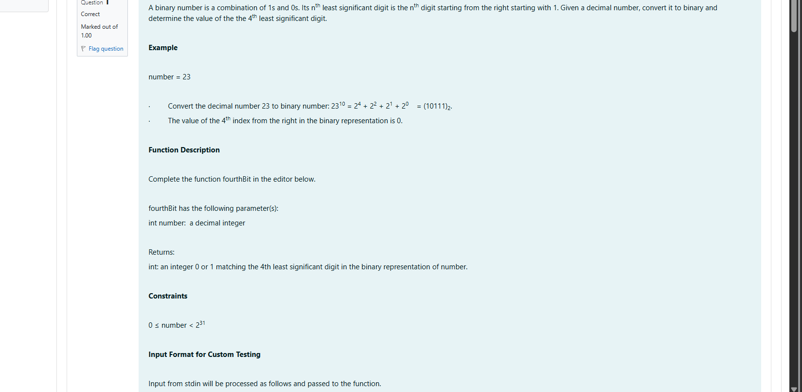

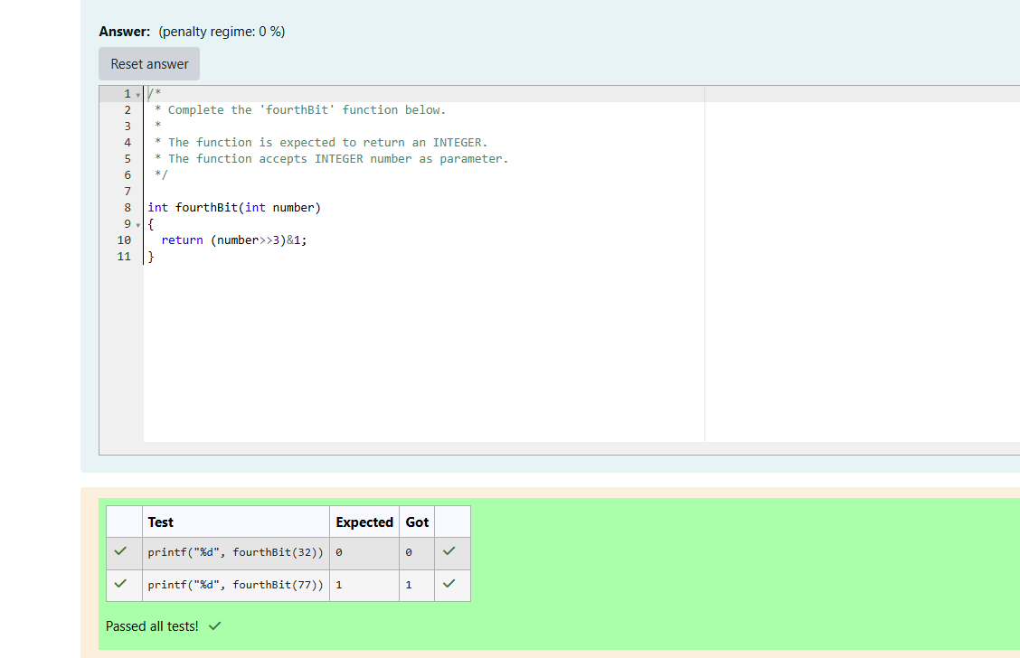

week -12-user-Defined Functions

coding

reg no:241801289

name : Tamilselvan .k

Q2

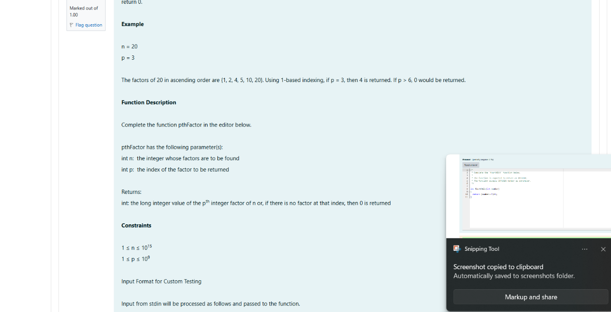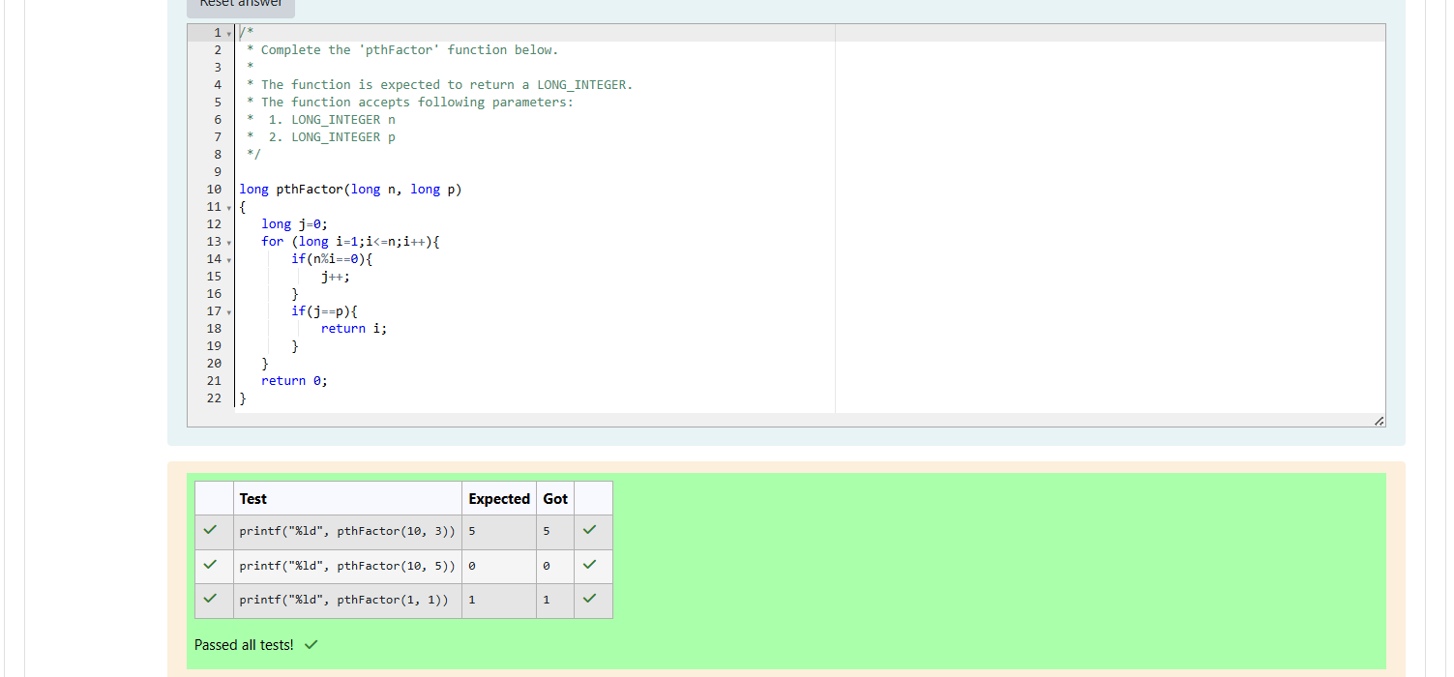

Week-12-recursive functions

Week-12-coding

Reg no:241801289

Name: Tamilselvan .k

Q1

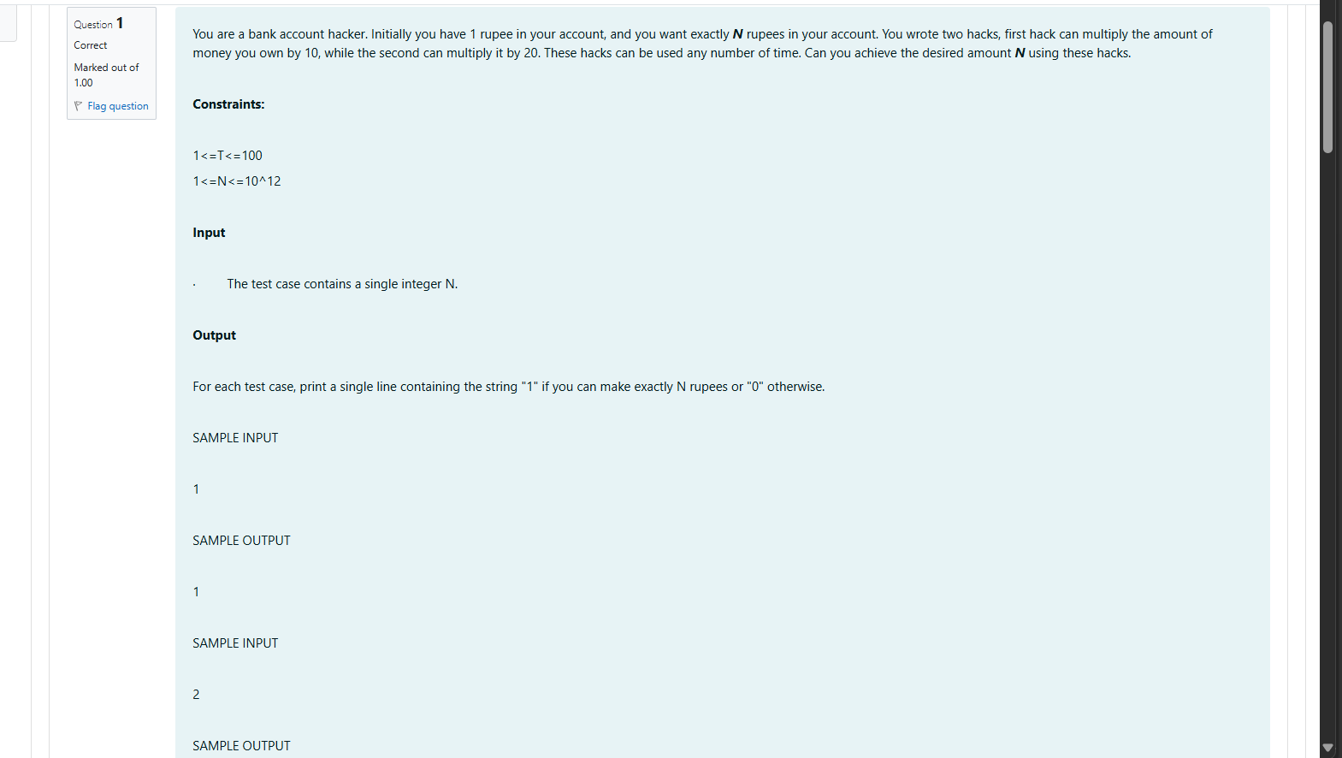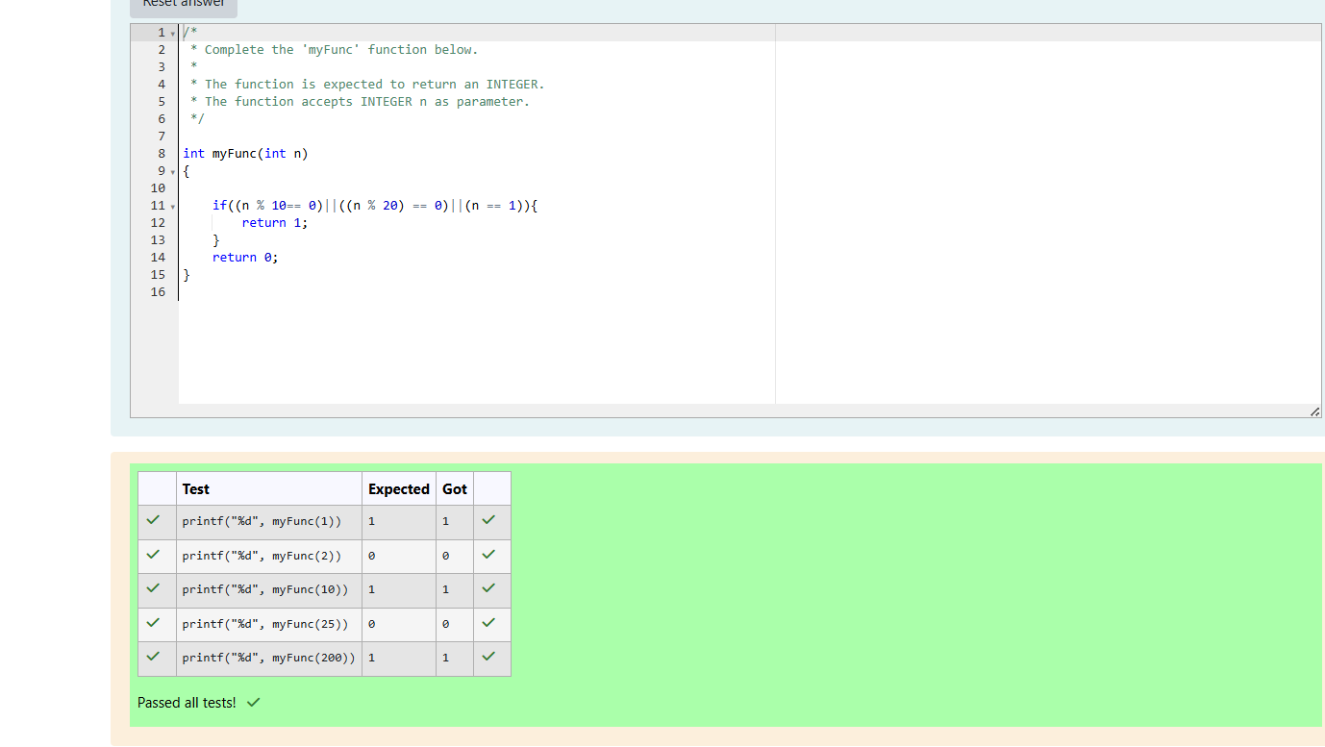

week -12-user-Defined Functions

reg no:241801289

name :Tamilselvan.k

Q2

